UNIT/05: CONSUMERISM
READING
IN THIS unIT YOU WILL
LEARN HOW TO
- identify topic sentences
- identify main and supporting ideas
- match headings with paragraphs
- use will and going to.

Lead-in

 | Which of these activities can you do at a shopping mall? Which can you see in the pictures?  Can you think of anything else you can do at a mall?
  01
  buy clothes | buy or rent an apartment | check your health
  go climbing | go in a hot air balloon | go to the beach
  have a snack | have a beauty treatment | have an expensive meal
  see a film | see an art exhibition | see plants and trees
  ski
  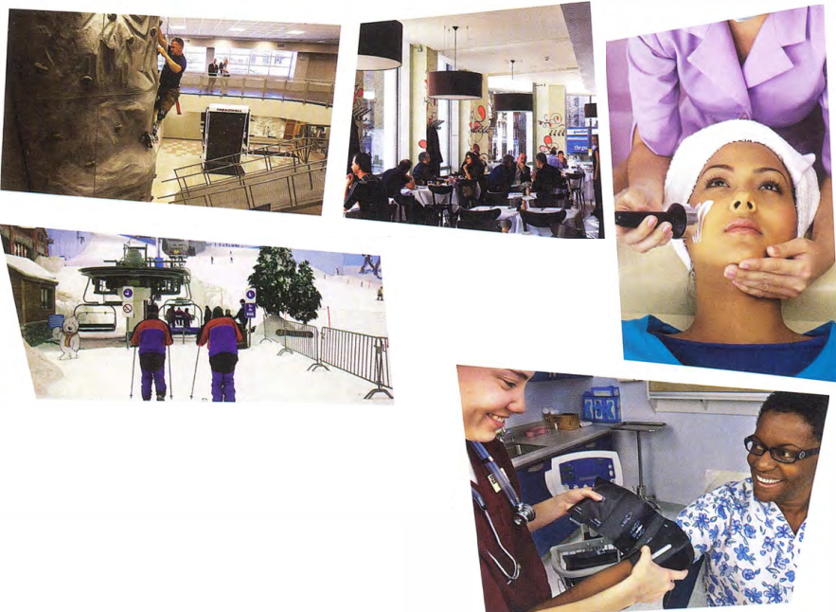

SKIM READING

 | Read the text in one minute. Answer the questions orally without looking at the text again.  - Which of the activities in exercise 1 were mentioned?  - Can you remember any places that were in the text?  - Is the text mainly about the past, present or future?
  02

THE FUTURE OF MALLS
A  Shopping malls have never been just about shopping. They began in the United States after the Second World War and, for the young, they were always a place to 'hang out' and be seen. However, the world has moved on, and just providing shops and a food court is no longer enough to keep malls alive. Malls became less popular at the start of the 21st century, mainly because of online shopping. There is even a website, deadmalls.com, which shows the end of many US malls. Malls need to change to survive. So what will the mall of the future look like?  B  Malls are already becoming bigger and better all over the world. Asia and not the US is now the 'mall capital' of the world and is home to the five largest malls in the world. China is home to the two largest. Some malls in the Middle East and East Asia are starting to specialise. It is predicted that this will happen more and more in the future. Some malls will only sell electrical items, for example, or only fashion for young people. Some malls will only include expensive shops or cheap shops, as already happens in Bangkok and Singapore.  C  Malls are becoming 'the new downtown', with cinemas, bowling alleys, climbing walls and even concert halls. Xanadu, a mall 30 km from Madrid, is a recreation centre for a family day out as well as a shopping centre, with ski slopes, minigolf, go-karts, balloon rides, bowling and billiards. We have always been able to grab a burger at the mall, but in the future we are going to see 'fine dining' too, with more expensive restaurants based at malls, as well as spas, fitness centres and art galleries. There are also going to be more apartments and office space so that more people can live, work, shop and be entertained in one location. | D  Mall owners are going to need to think of new ideas to remain in business. One growing trend is the seasonal changes in the mall. It began with having Santa Claus in December, but now there are 'pop-ups' -temporary shops, stalls and kiosks - for other seasons and events. Brent Cross in North London has an 'urban beach' in summer, and its main lobby has different promotions and events every week, from bungee jumping for kids to free health checks.  E  So, we have looked at the facilities malls will need to offer. Malls will need to consider the environment too. There will be more open-air malls and more natural features. Mall designers will have to make sure people can get there by public transport. They will also need to use more natural sources of heat and light. We will see more plants, trees, grass and even waterfalls at our local malls in the future.  F  The future of malls looks exciting: there will be 'virtual malls' and technology will be used within malls to help us shop, find bargains and even park our car. With all these creative innovations, the mall will go from strength to strength.

[[[[[[[[[[MATCHING HEADINGS]
◉ Matching headings tests your ability to summarise and understand the main idea of a paragraph.
You are given a list of headings (more than the number of paragraphs) and you must choose a suitable heading for each paragraph.
To match headings, you need to be able to find the main idea of a paragraph. You can usually find one sentence that sums up the main idea. This is the topic sentence. This has been highlighted in paragraph A: Molls need to change to survive.
The sentence Malls need to change to survive is supported by evidence in the paragraph, including:
- The world has moved on.
- Malls became less popular at the start of the 21st century, mainly because of online shopping.
- There is even a website, deadmalls.com, which shows the end of many US malls.

TOPIC SENTENCES AND MAIN AND SUPPORTING IDEAS

 | The topic sentence in paragraph B is Malls are already becoming bigger and better all over the world. Write two pieces of evidence from paragraph B which support the topic sentence. | TIP 03
  03
  The topic sentence is often, but not always, the first sentence in a paragraph, so that is the first place to look.
 | Find the topic sentences in paragraphs C, D and E.
  04
 | Below is one supporting idea for each of paragraphs C, D and E. Add one more for each paragraph. Write the supporting ideas in your own words.
  05
  - Xanadu... is a recreation centre for a family day out as well as a shopping centre.
  - Brent Cross ... has different promotions and events every week.
  - There will be more open-air malls and more natural features.

PARAPHRASE

 | TIP
  ◉ In a 'matching headings' task, the headings you have to match will be a paraphrase of the main idea of the paragraph. Don't expect the same words to be used in the headings and the passage. The headings may contain synonyms (words which mean the same) and antonyms (words which mean the opposite) or they may use paraphrase (phrases which have a similar meaning to words in the passage).
  For example, a heading for paragraph A in The future of malls might be 'Adapt or die'. This is a paraphrase of the main idea 'Malls need to change to survive'.
  change-adapt (synonyms) survive - die (antonyms)
  As you prepare for your exam, make a list of synonyms in your notebook. Knowing different ways to say things is one of the key skills in IELTS.

 | In the test, there are always more headings than you need. Read these headings for paragraphs B to E (they are not in the right order).  - Innovate and stay alive  - Fast food paradise  - Expanding and improving  - Malls and the natural world  - A new city centre
  06
 | Match the words and phrases 1-6 (from the headings above) with the words and phrases a-f (from the topic sentences of paragraphs B-E).
  07
  - innovate  - stay alive  - expanding  - improving  - natural world  - city centre | - becoming bigger  - environment  - think of new ideas  - downtown  - remain in business  - becoming better
 | Choose a heading from exercise 6 for paragraphs B to E.  Write the correct number i-v in the gaps.  Paragraph B  Paragraph C  Paragraph D  Paragraph E
  08

GRAMMAR FOCUS: FUTURE FORMS

 | Find examples of future forms in the passage The future of malls. Which two ways of talking about the future are used? Write one example of each.
  09

◉ Will + infinitive and going to + infinitive are both used to talk about the future.
Going to is used when there is a link to the present, for example if something is already planned or a change has started:
Mall owners are going to need to think of new ideas to remain in business.
We see from the text that many malls have already started thinking of new ideas.
Will + infinitive is used for prediction: something the writer believes about the future. It does not
have to be based on present evidence:
... the mall will go from strength to strength.
This is the writer's prediction or belief about the future.

 | Complete the sentences with the correct form of will or going to.  - Look at these plans for the new mall! There ___ be a climbing wall!  - This newspaper article says they ___ spend $25 million on the project.  - I think it ___ be great when it is finished!  - I agree, but I'm afraid many local businesses ___ have to close.  - I heard there ___ be 12 different restaurants!  - I expect most of the shops ___ be expensive ones.
  10

[[[[[[[[[[EXAM SKILLS]
 | Which paragraph in the passage Markets around the world contains information on the following? Write the correct letter, A-G.  - markets put on at a particular time of year  - markets where anyone can sell anything  - markets selling things to eat  - advice for people who want to dress differently from others  - examples of markets outside Europe
  11
 | The reading passage has seven paragraphs, A-G. Choose the correct heading for paragraphs B-F from the list of headings (i-vii) below. Write the correct number, i-vii. There are two headings you won't need.  - Paragraph B  - Paragraph C  - Paragraph D  - Paragraph E  - Paragraph F
  10
  List of headings
  - Local art and craft work to take home
  - Inexpensive things to eat straight from the countryside
  - Toys for children of all ages
  - Invent a new style for yourself at bargain prices
  - London has the best markets
  - Find gifts for winter celebrations
  - Sell what you don't need

Markets around the world
A  We have become so used to shopping in big supermarkets and chain stores, identical in every town, that we have forgotten about one important way to shop-markets. Markets are found in every country in the world, but wherever you go they are different and reveal the local culture- and agriculture. From farmers markets selling fresh produce to craft and antique markets, they are the best place to find something unique at a great price.  B  Food is at its cheapest and freshest  in markets. Farmers often sell direct to the consumer, without all the packaging, shipping and advertising that increases costs in shops and supermarkets. You can often find unusual products and those that are not mass-produced. Food markets vary hugely according to where they are in the world. For example the Kauppatori market in Helsinki, Finland sells moose, reindeer and bear salami. Wherever you are, food will be locally produced and reasonably priced.  C  Markets are also good places to buy clothes. Some sell cheap new and second-hand clothes, while others specialise in vintage or ethically made clothes and original items. The markets of London are some of the best in the world for those who want to create a unique look for themselves. Many new designers start with a market stall, so if you are looking for a totally original item of clothing, you could get something really special at a bargain price at Brick Lane, Spitalfields or Portobello Road markets. | D  Another type of market is a flea market. This is a much more informal type of market, where second-hand products can be sold by anyone. If you have unwanted items at home, you could take them to a flea market and sell them yourself. There are also antiques and possibly local crafts at this kind of market. In some parts of the world there may not even be stalls, rather, vendors lay out their goods on a sheet on the ground. In other parts of the world, flea markets have developed into car boot sales, where people sell their unwanted items from their cars.  E  In some places, markets are directed at visitors and tend to sell handicrafts typical of the region. For many tourists, a visit to a nearby market to buy souvenirs is an important part of their holiday. Guadalajara in Mexico has a huge range of traditional textiles, glassware, ceramics and art works and Seoul in Korea has some wonderful original designs of all kinds of products at affordable prices. Countries in the Middle East usually have beautiful hand-made rugs and carpets, and Indian markets sell colourful handloom fabrics and beautiful silk scarves.  F  In Europe, Christmas is the time when seasonal markets are held to sell decorations and gifts for the festive season. One of the most famous of these is held in Wenceslas Square in Prague in the Czech Republic. The market is made up of colourfully decorated wooden huts selling traditional handicrafts, embroidered lace, wooden toys, scented candles, Christmas tree ornaments, and puppets and dolls beautifully dressed in traditional costumes. This looks very pretty, especially in the snow.  G  So, wherever you are in the world and whatever you are looking for, there is a market for you. You can get all kinds of unusual things at great prices.

UNIT/05: CONSUMERISM
WRITING
IN THIS unIT YOU WILL
LEARN HOW TO
- organise a Part 2 essay
- write an introduction
- write about points for and against, and give opinions
- give examples and evidence to support your views.

Lead-in

 | Put the words and phrases into the correct column.
  01
  advantages | all things considered | benefits
  disadvantages | drawbacks | in my view
  negative aspects | positive aspects | personally
  Good points | Bad points | Opinion

 | These sentences are from an essay on the advantages and disadvantages of shopping online. Are they talking about good points (G), bad points (B) or giving an opinion (O)? Write G, B or O. The first one has been done for you.  - A wider range of products is available online. G  - You can't try on clothes and shoes if you buy online.  - I prefer going to shops and choosing things in person.  - There is no need to carry heavy shopping to your car.  - You save money on petrol, parking or bus fares.  - Goods might be delivered when you are out.  - It isn't a good idea to give your credit card details online.  - You often have to pay a lot for postage and wait for your goods.  - I think it is better to support local shops.
  02
[[[[[[[[[[PART 2 QUESTION TYPES]
◉ In Part 2 you have to write an essay of about 250 words. There are different types of question in Part 2, and you must write a well-organised answer considering different points of view.
The topics in Part 2 are all general and do not need special knowledge.

 | Three of the question types you might find in Part 2 are:  - Do you agree (or disagree) that...?  - Do the advantages/benefits of ... outweigh the disadvantages/drawbacks?  - Discuss two different views and give your opinion.  Match the question types 1-3 with what you have to do (a-c).  - Say if you think there are more good points than bad points.  - Write about both sides and say what you think.  - Give your opinion on this. | TIP 03
  03
  Read newspapers and websites to find out about current issues.
 | Look at the following question.  Do you agree that supermarkets are a threat to small shops and local communities?  Decide on your own opinion. Choose from these options.  - I strongly agree. Supermarkets will force small shops to close and this will damage local communities.  - I agree to some extent. There may be a slight threat to small shops and local communities.  - I generally disagree. There is a place for both small shops and supermarkets.  - I strongly disagree. Supermarkets will not have an impact on small shops and local communities. | TIP 04
  04
  Do you agree that supermarkets are a threat to small shops and local communities?
  Avoid being totally neutral: even if you don't have an opinion on the topic, it is better to agree or disagree. Choose the side you can find most points for.

 | The same topic could be expressed as a different question type:  Are these advantages or disadvantages of supermarkets?  - They are cheap.  - There are many different products.  - You often need a car to get there.  - You don't usually meet your friends there.  - Food is usually fresh.  - There are sometimes queues at the checkout.  - There is plenty of free parking.  - Small shops lose their customers.
  05
  Do the advantages of supermarkets outweigh the disadvantages?

WRITING AN INTRODUCTION

◉It is important to begin your essay with a clear introduction.
An introduction should contain:
- background information about the topic or a description of the present situation. (Nowadays you can find a supermarket in every town.)
- a brief plan of your essay. (I will consider both sides of the argument and give my own view.)
An introduction may also contain:
- your opinion. (I think there are too many supermarkets.)
An introduction should not contain:
- your main points for or against. (Supermarkets give jobs to local people.)
- supporting evidence for the points. (In my city in China we have five different supermarkets.)

 | Which of these, A or B, is the better introduction for the essay topic in exercise 5? Give reasons.  - I totally agree that the advantages of supermarkets outweigh the disadvantages. There are many benefits - cheap prices, plenty of choice, late opening hours, and only a few drawbacks. In this essay I will explain my opinion.  - Nowadays you can find a supermarket in every town. There are often several to choose from and there is strong competition between them. This clearly has many benefits, but there are some drawbacks too. I will consider both sides of the argument and give my own view.
  06
 | Study the information about introductions in the box above, and then read the following Part 2 question and a student's introduction. What are the good and bad things about this introduction?  Online shopping has increased in popularity over the last few years. People now shop for a wide variety of items on websites. Other people still prefer going to the shops to buy things. There are a lot of reasons why online shopping is growing. One of them is that there is a wider choice of items. In this essay, I will consider each of these opinions and give my own view.
  07
  Some people think shopping online is better, while others prefer going to the shops. Discuss both these views and give your own opinion.

MAKING COMPARISONS

 | Look at diagram 1 and complete the sentences about the pie chart with the words in the box. One word is used twice.  - The ___ popular type of takeaway is Chinese.  - The three ___ popular types are Mexican, Greek and Japanese.  - Italian takeaways are slightly ___ popular than British takeaways.  - Japanese food is ___ popular than Thai food.  - ___ people like Chinese food than Indian food.  - ___ people like Mexican food than Thai food.
  05
  fewer | least | less | more | most

GRAMMAR FOCUS: COUNTABLE AND UNCOUNTABLE NOUNS

 | Choose the correct words to make true sentences.  More and less are used with countable / uncountable nouns.  More and fewer are used with countable / uncountable nouns.
  06

 | Put the nouns into the correct column.
  07
  restaurant | coffee | farm | country | home | land
  language | meat | oil | person | home animal | sand
  Countable | Uncountable
 | Complete the sentences with more, less or fewer. Use the information in the chart.  - China has ___ land than India.  - India has ___ land than China.  - In India, ___ people live in cities than in China.  - India has ___ official languages than China.
  08
  Countable | China | India
  land | 9,596,960 square km | 3,287,263 square km
  percentage of population living in cities | 50.5% | 31.3%
  official languages | Mandarin Chinese | 22 official languages

GRAMMAR FOCUS: ARTICLES

 | Correct the errors with articles in these sentences about diagrams 1 and 2.  - Number of Indian restaurants in UK has risen.  - The Chinese food is the most popular.  - Second most popular food is Indian.  - There was small drop in the number of Indian restaurants in 2011.  - There were about thousand Indian restaurants in 1970.
  09

DESCRIBING DIAGRAMS WITHOUT EXACT NUMBERS

 | Some graphs or charts do not give the exact numbers. It is important to show that the number you use is not exact. Match these numbers with their description.
  10
  - 8950  - 2019  - 500,070  - 3946  - 103  - 7223 | - approximately 4000  - about a hundred  - just under 9000  - between 7000 and 7500  - around half a million  - a little over 2000

 | Look at these examples from a description of diagram 2.  There were about 500 Indian restaurants in the UK in 1960.  The number rose from approximately 5000 in 1990 to just under 8000 in 2000.  The figure for 1997 was around 7500.  From 2007 to 2015 the number of restaurants was between 9000 and 9500. In 1970 there were a little over 1000 Indian restaurants.  Use the expressions in bold to complete the sentences about diagram 3, which shows the market share of four supermarkets.
  11
  - In 1995, Foodhall had ___ 20% of the market, while Finco had ___ 20%.  - In 1995, Bestway's share of the market was ___ 5%.  - In 2005, all the supermarkets had ___ 11% and 30% of the market.  - In both 2005 and 2015, Alton's share of the market was ___ 16%.  - Finco had the biggest market share in 2005, which was ___ 30%. | 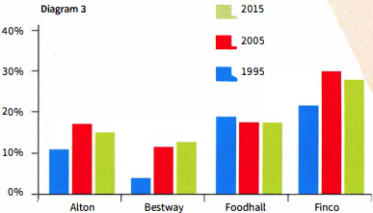

STUDYING A MODEL ANSWER: AVOIDING 'OUTSIDE' INFORMATION

 | Read the model answer, which is based on diagrams 1 and 2. Two sentences should not be included. Can you find them?
  12
 | Read the model answer again and find:  - the overview  - a sentence that explains the link between the two charts  - a comparison  - a passive form  - a way of saying '1990 to 2000'  - an expression meaning 'has not changed much'  - an expression used to avoid exact numbers  TIP 13 | MODEL ANSWER
  13
  Never include any information that is not shown in the diagram. Even if you know a lot about the data given, do not try to explain the reasons for it or give your own opinion.
  The pie chart shows which type of takeaway food is the most popular in the UK, while the bar chart shows how many Indian restaurants existed in the UK between 1960 and 2015. We can see that Chinese and Indian takeaways are the favourites, and that the number of Indian restaurants in the UK rose steadily during this period.
  The pie chart shows that Chinese and Indian takeaways are much more popular than all the others, at 34% and 26%, There are another two types that quite a lot of people like. These are Italian at 10% and British at 9%. It is not surprising that people in the UK like British food as fish and chips is the national dish, Greek, Japanese and Mexican were only chosen by 1% of people.
  The pie chart shows us that Indian food is popular and the bar chart shows how its popularity grew. Even my village has an Indian restaurant! There was a rising trend from 1960 onwards. The increase was greatest in the 1990s, from about 5000 restaurants in 1990 to almost 8000 in 2000. Since 2007, the number has remained stable at just over 9000.

[[[[[[[[[EXAM SKILLS]
 | Read the exam question below and study the charts, then answer these questions about the data.
  14
  - What is the main trend revealed in the bar chart?  - Which ten-year period showed the first significant increase?  - What happened in the ten-year period after that?  - What is the link between the two charts?  - In 2015, what percentage of people were severely obese?  - Which was the largest group in 2015? | You should spend about 20 minutes on this task.  The bar chart shows the percentage of adults who were overweight or obese (too fat or much too fat) in one country from 1965 to 2015. The pie chart shows the proportion of adults who were overweight, obese or severely obese in 2015.  Summarise the information by selecting and reporting the main features, and make comparisons where relevant.  Write at least 150 words.
  Percentage of adults who are overweight or obese  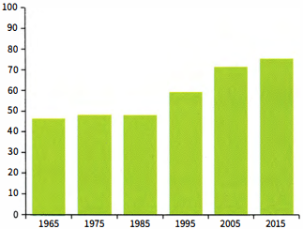 | Weight range of the adult population 2015  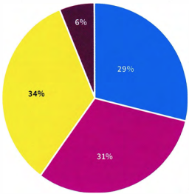
    ☐ Healthy or underweight | ☐ Obese (too fat)
    ☐ Overweight | ☐ Severely obese (dangerously fat)
 | Now write your report. Remember:  - Include an overview.  - Don't try to include all the data.  - Don't include anything from outside the data.
  15

UNIT/05: CONSUMERISM
LISTENING
IN THIS unIT YOU WILL
LEARN HOW TO
- find synonyms and paraphrase in matching tasks
- identify 'distractors' in matching tasks
- answer classification tasks.

Lead-in
 | Pictures A-G show different areas of work or study. Match the pictures with the words in the box.
  01
  bake | boil | fry | grill
  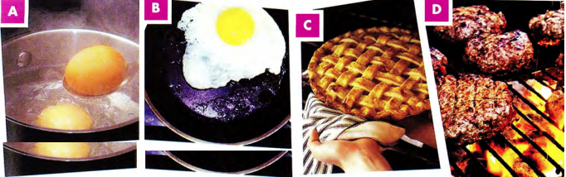
 | Match the words with the type of food they are. Put them in the correct column.
  02
  apples | bananas | beef | biscuits | burger | cake | steak | potatoes
  carrots | chocolate | lamb | cucumbers | pastries | pears | peas | strawberries
  Meat dishes | Vegetables | Fruits | Sweets

[[[[[[[[[[MATCHING TASKS]
 | Listen to two friends talking about a party they are planning. Match Mike's suggestions with Jane's answers.  32  What are they going to prepare?
  03
  Suggestions  - What do you think about preparing a Mexican meal?  - We could have pizza. Everybody likes pizza.  - I know! We could have salad and roast chicken. | Answers  - I think we should have something healthier.  - That sounds like a good idea. Let's do that.  - I think it might be too spicy for some people.
  ◉ In matching tasks in the Listening test, you may hear information about several of the options, but only one of the answers is correct.

 | Listen to two friends talking about preparing a meal. How are they going to prepare the potatoes?  33  Why are the other answers incorrect?
  04
  - boil | - bake | - fry
  ◉ In matching tasks in the IELTS test:
  - you do not need to use all of the letters. You should put one letter next to each numbered question.
  - the questions follow the same order as the information on the recording which you need for the answers.
 | Listen to two friends discussing food shopping. Match the names of the shops (1-3) with the different types of food, A-D.  34  Which option didn't match any of the shops? |  | TIP 04
  05
  - Arcadia  - Best Buy  - Hampton's | Types of food  - vegetables  - meat  - fruit  - sweets
  Listen carefully to what is said about all the options to make sure you choose the correct one.

 | You will hear a radio programme in which two people are discussing the different restaurants in a town.  Look at the names of restaurants (1-3) and the list of types of restaurant.  Match each restaurant with the correct type, A-G.  35  Which option didn't match any of the shops?
  06
  - Adam's  - The Duke  - The Tower | Types of restaurant  - vegetarian  - steakhouse  - seafood  - Italian  - international  - French  - fast food
 | After you have checked your answers, look at the Listening script on page 182 and check why the other options were not correct.
  07
 | Look at the Listening script again and find words that mean the following:  - crowded  - delicious  - cheap  - smart  - inexpensive
  08

FOLLOWING A CONVERSATION

 | Choose the option, A, B or C which does NOT mean the same as the first sentence.  - The price of food in the restaurant is cheap.  - The price of a meal in the restaurant is reasonable.  - The restaurant is excellent if you want a budget meal.  - The food in the restaurant is overpriced.  - Marco cooked us a really tasty meal.  - The meal Marco prepared was delicious.  - Marco cooked us a really unappetising meal.  - The meal Marco made for us was mouth-watering.  - We were served food that was cooked in the old-fashioned way.  - The meal we had was very contemporary in style.  - The meal we had was very traditional.  - The meal was made from a historic recipe.  - When I went to Thailand, I really enjoyed trying the street food.  - I really liked tasting the food that was sold outdoors in Thailand.  - In Thailand I loved the food we bought from stalls in the streets.  - I enjoyed eating at restaurants when I was in Thailand.  - The chef at the Lodge Hotel is very skilful.  - The chef at the Lodge Hotel is bad at his job.  - The chef at the Lodge Hotel has a lot of expertise.  - The chef at the Lodge Hotel is highly trained.  - The ingredients for the recipe can be changed to ones you have available.  - You can use different ingredients to make this dish if you can't find everything.  - You can be flexible about what ingredients you add to this recipe.  - You should follow the recipe strictly or it won't taste good.  - The chef at the new restaurant is famous across the country.  - The chef at the new restaurant is well known nationally.  - The chef at the new restaurant is recognised across the country.  - The chef at the new restaurant is unknown outside of his town.  - I didn't like the soup; it was too spicy.  - The soup had too much pepper.  - The soup wasn't tasty.  - The soup was a bit too hot for my taste.
  09
 | Underline the words which helped you find the answers to exercise 9.
  10

[[[[[[[[[[CLASSIFICATION TASKS]
◉ Sometimes in the test you will be asked to match several pieces of information with three different options. Like with other matching exercises, you must listen for ideas, since the same word will often not be used on the recording as in the question.
The options with letters (A-C) can be used more than once. The numbered information you must find (1-5) will be in the order that you will hear it.

 | Listen to a famous TV chef talking about different countries and their cuisines. Match the statements with the correct country, A-C.  36  - They use chopsticks made of several different materials.  - You can find a lot of different types of regional cooking here.  - This place is famous for hot, peppery food.  - In this country people use recipes that came from different countries.  - This country is well known for its grilled meat.  - China  - Japan  - Korea
  11
[[[[[[[[[[EXAM SKILLS]

 | You are going to hear an interview with a chef about a TV programme he has made about food in China.  Choose FOUR answers from the types of food in the box and write the correct letter A-F next to questions 1-4.  37
  12
  Which of the foods:  - is often enjoyed by children?  - can be cooked in a short time by  - the dinner guests?  - needs expertise to make?  - can be adapted to your tastes? | Types of food  - Beijing duck  - kebabs  - dumplings  - noodles  - hotpot  - jellyfish

UNIT/05: CONSUMERISM
SPEAKING
IN THIS unIT YOU WILL
LEARN HOW TO
- talk about food in your country (Speaking Part 1)
- use the preparation time to collect your ideas for Part 2
- organise your talk (Speaking Part 2).

Lead-in

 | Look at the photographs of different dishes. Which ingredients do you think are used to make each one? Match the pictures with the words in the box. Some ingredients are used more than once.
  01
  beef | cabbage | carrots | cheese | chicken
  egg | tomatoes | yoghurt | ginger | chillies
  lamb | onions | soy sauce | rice | spices
  flour | garlic
  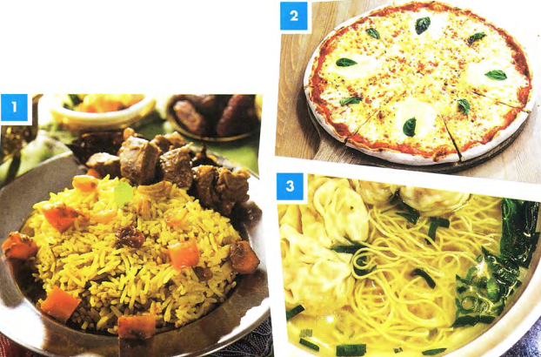
 | With a partner, discuss your favourite food. What ingredients are used to make it?
  02

GRAMMAR FOCUS: COUNTABLE AND UNCOUNTABLE NOUNS

◉Some things we eat are countable and some are uncountable. This changes some of the words we use to talk about them.
Examples:
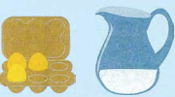  There are some eggs.  There is some water. | 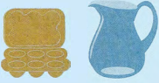  There aren't any eggs.  There isn't any water.
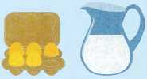  There are a lot of eggs.  There's a lot of water. | 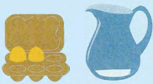  There aren't many eggs.  There isn't much water.

 | With a partner, describe what you can see in the fridge.  Use the sentences below to help you.
  03
  - There ___ eggs.  - There ___ cheese.  - There ___ milk.  - There ___ carrots.  - There ___ bananas.  - There ___ orange juice. | 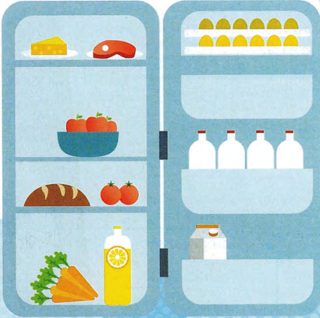

FOLLOWING A CONVERSATION

 | Listen, then read Mohammed's answers to these Part 1 questions about food. Are the phrases in bold positive or negative opinions?  38
  04
  Examiner | What kind of food is popular in your country?
  Mohammed | These days a lot of young people actually enjoy Western food like pizza and fried chicken. Our national food is often too spicy, especially for children and foreigners, and also it takes too long to cook. I think that it's delicious though!
  Examiner | What do you think of Western food?
  Mohammed | Well, I suppose Western food is quick to make and is tasty too, so everyone can eat it without too much trouble. I think that a lot of people like food to be convenient because they're so busy nowadays.  Is there any kind of food you don't like?
  Examiner | Is there any kind of food you don't like?
  Mohammed | Yes, I'm not keen on sushi at all. It's so strange eating something that hasn't been cooked. I know it's very fresh and healthy but I just don't like the taste and I can't stand the texture - it's too chewy for me.
  Positive | Negative
 | Answer the three questions in exercise 4 with a partner. Use some of the positive and negative phrases in the box.
  05

USING THE PREPARATION TIME IN PART 2

 | Listen, then read Mohammed's answers to these Part 1 questions about food. Are the phrases in bold positive or negative opinions?  39  Look at the task card and listen to Angelica talking about a meal that is popular in her country. Then answer the questions below.  Describe a popular meal from your country that you like to eat.  You should say:  - what the meal is  - why it is popular in your country  - why you like it  and say why you would recommend it to a visitor to your country.  - Did Angelica introduce what she was going to talk about?  - What was the meal that Angelica described?  - Why is it popular in her country?  - Why does she like it?  - Why would she recommend it to visitors to her country?
  06

 | You only have one minute to make notes on the topic for Part 2, so it is a good idea to write down key words and phrases. Match the four points on the card with some key words that another student wrote down (a-d).
  07
  Describe a popular meal from your country that you like to eat.  You should say:  - what the meal is ⁽¹⁾  - why it is popular in your country ⁽²⁾  - why you like it ⁽³⁾  - and say why you would recommend it to a visitor to your country. ⁽⁴⁾  - We love meat, traditional, lots of sheep!, proud of our cuisine  - better in Turkey than UK, different types (Shawarma, doner, etc.), most famous street food  - I'm busy buy quickly, tasty, juicy, reminds me of beach holidays  - lamb, slowly grilled, spices, garlic - serve with rice / bread / vegetables | TIP 07
    Remember that you need to speak for 1-2 minutes on the topic you are given, so in this case make sure you choose a meal you can talk about easily.
 | Spend one minute writing notes to the questions about a popular meal in your country. | TIP 07
  08
  It is important to make notes and try to cover every point on the card.
 | Take it in turns with your partner to speak for two minutes. If your partner stops, think of questions to ask them.  Example  - l used to eat it at the beach in summer...  - Who did you go to the beach with?
  09

[[[[[[[[[[ORGANISING A PART 2 TALK]
◉ When you are asked to speak on a topic for two minutes you should try and organise your talk:
- Introduction - say what you are going to talk about.
- Body-answer the questions on the card.
- Conclusion-briefly give a conclusion to your talk.

 | Can you use the phrases in italics in an introduction (1) or a conclusion (C)?  - I'm going to talk about my favourite food, paella.  - I'd like to tell you about pelmeni - it's a very famous dish in my country.  - So, it is one of the most famous foods in my country for those reasons.  - To sum up, I think it's popular because it is easy to cook.  - As you can see, it's a tasty and healthy dish and that's why it's popular.
  10
  ◉ You can help to structure your talk by saying why you chose the topic:
  I chose this topic because...
  You can also use words like firstly/first of all, secondly, thirdly to help you (and the examiner) keep track of your talk.
 | Work in pairs. Look at the students' notes relating to the task card below.  Spend one minute thinking how you will structure your talk, then take it in turns to practise presenting the information.  Describe your favourite food.  You should say:  - what the food is  - how often you eat it  - how the food is made  and say if you can make the meal yourself.
  11
  Student A | Student B
  Pizza - delicious, easy cook, filling  on Fridays - late lectures, special day  oven, bread, add cheese, tomato, toppings  only frozen! / take-away  Conclusion - easy and tasty | Vegetable soup - tasty, healthy, cheap at weekends, winter - long time to cook, better in cold weather  chop vegetables, boil, wait  yes, love cooking, relaxing, fun  Conclusion - enjoy making, filling, economical

[[[[[[[[[[SPEAKING TEST - PART 2]
 | Read the task card and spend one minute preparing your talk. Take it in turns to speak. Try to speak for two minutes.  Describe a special occasion when you had a really enjoyable meal.  You should say:  - what the occasion was  - who was at the meal  - what you ate  and explain why the meal was so enjoyable.  Remember to:  - make notes of key ideas  - introduce your talk  - structure your talk  - give it a conclusion. | TIP 12
  12
  It is good to use different adjectives in this part of the test. Think of different ways of saying the words and avoid words like good and bad.

[[[[[[[[[[SENTENCE COMPLETION]
TIP 04
It is important to listen carefully to the ending of words. For example, words ending in -ology and-tion can be used to talk about different areas of work or study. Words that end in -er may refer to people and jobs.

◉ In this type of task you complete sentences by writing up to three words, or two words and/or a number, in the gaps. The instructions tell you how many words you can write.
The gaps can come
- at the beginning of the sentence
- in the middle of the sentence
- at the end of the sentence.
The sentences have a main verb and a subject.

FOLLOWING A CONVERSATION

26
MODEL ANSWER
The pie chart shows which type of takeaway food is the most popular in the UK, while the bar chart shows how many Indian restaurants existed in the UK between 1960 and 2015. We can see that Chinese and Indian takeaways are the favourites, and that the number of Indian restaurants in the UK rose steadily during this period.
The pie chart shows that Chinese and Indian takeaways are much more popular than all the others, at 34% and 26%, There are another two types that quite a lot of people like. These are Italian at 10% and British at 9%. It is not surprising that people in the UK like British food as fish and chips is the national dish, Greek, Japanese and Mexican were only chosen by 1% of people.
The pie chart shows us that Indian food is popular and the bar chart shows how its popularity grew. Even my village has an Indian restaurant! There was a rising trend from 1960 onwards. The increase was greatest in the 1990s, from about 5000 restaurants in 1990 to almost 8000 in 2000. Since 2007, the number has remained stable at just over 9000.

